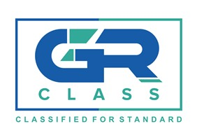
Certificate No. | -SSPA-
Control Number:

CERTIFICATE OF APPROVAL / AMENDMENT ⁽¹⁾
SHIP SECURITY PLAN

This is to certify that the Ship Security Plan of the vessel:
Has | een approved on behalf of the Government of | under the provisions set forth in the
International Ship and Facility Security Code, in compliance with SOLAS Chapter XI-2 and the ISPS Code Part A Section 9, and taking
into account the relevant provisions of Part B.

Distinctive Number or Letters
Port of Registry
Type of ship
Gross Tonnage
IMO No.
Name and address of the Company
Company Identification Number
Place and Date of approval
This approval does not absolve the Master of his responsibilities to take appropriate actions as deemed necessary for operating the vessel in a safe and secure manner. No addition or amendment is to be made to the approved manual without prior approval of GR Class – Classified For Standard , except of minor editorial changes. This approval will be invalid upon change of flag of the vessel or when a new company assumes the responsibility for the operation this ship. The Plan shall be protected from unauthorized access or disclosure.
Signature of authorized official issuing the Certificate
Name:
GR CLASS-CLASSIFED FOR STANDARD

